WE WELCOME MARCH AND ALL THE EXCITEMENT IT BRINGS TO OUR COMMUNITY AND OUR CHURCH...after all who doesn’t love a bargain!!

OUR THRIFT SALE WILL OPEN OUR DOORS TO THE PUBLIC
ON MARCH 14TH, MARCH 15TH AND WRAP UP ON MARCH 16TH
In the interim we have a team of VERY HARD WORKERS who are at the church daily sorting, hanging clothing, pricing items, setting up displays, organizing what goes where, etc., etc., etc.!!
Simply put, it’s a lot of hard work that radiates much shared joy. It puts a smile on my face when our core team of volunteers from our church call the people donating by their first names. “Hi Estelle…what do you have for us today?”
SALE DAYS…
3/14 THURSDAY 4:00PM – 7:00PM
3/15 FRIDAY 10:00AM-7:00PM…..MIM HOPES TO VISIT US ON FRIDAY!!
3/16 SATURDAY 10:00AM-3:00PM

Our proceeds will be equally distributed between the New Providence CSA, the LINC program and our scholarship fund.
ENVIRONMENTALISTS WANTED
The Stewards of the Earth Committee has several subcommittees, one of which is called “Conservation Action.” The Conservation Action subcommittee will examine ways in which environmentally sound endeavors may benefit the church and/or its congregants.
If you have an interest in this area and are willing to assist our group, please contact Lynn Franklin at lmkfranklin@verizon.net or 908-755-6276. If using the telephone, an answering machine is present 24/7. Leave a message and I’ll contact you.
Thank you
Lynn Franklin
WE ARE IN NEED OF BAGS FOR OUR BOOK MISSION
Should you have any extra plastic shopping bags please drop them off at the church office. Our book mission ladies are in dire need of them. We transport our books to Newark in bags and our last drop off used 30 bags!!
CALLING ALL USHERS
Our worship committee has once again set up a schedule of volunteers to usher our Sunday services. This was always something we practiced prior to the Pandemic and somehow afterwards it simply got lost.
The role of this volunteer position includes the following tasks…
- Arriving 20 minutes before service to confirm that lights and fans are turned on
- Greet people with our bulletin as they enter our service
- Assist with elevator if necessary
- Being the acolyte for our service
- Doing the collection
- Turning off lights, fans, closing the window shutters and locking the door in our narthex
LOSS OF A CHILD PRAYER SERVICE

The Church of the Little Flower in Berkeley Heights will be holding a prayer service for anyone who has lost a child on Sunday, March 10th at 2pm.

Should you have questions please contact Dan Grossano, Pastoral Associate for Ministries at 908-464-1585 or pastoral110.lf@gmail.com

SEED BLOCKS FOR OUR GIVING GARDEN

Sally Hoffman has been busy planting these seeds in preparation of that day in spring when we open our Giving Garden!
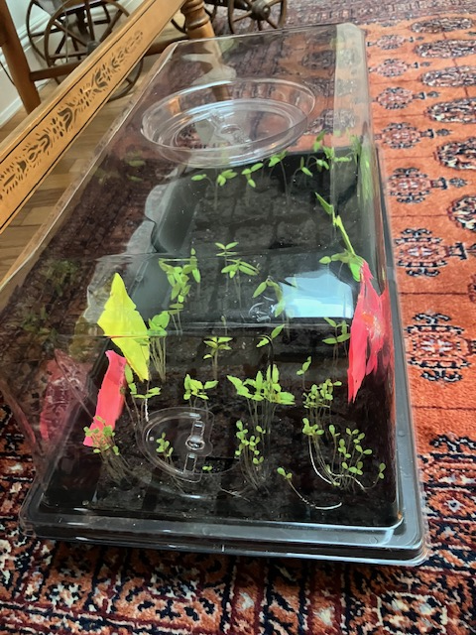

MARCH HAPPENINGS
March 12th 10:30am Book Mission
7:00pm Trustee Meeting
March 13th 10:00am Prayer Call
March 14th 4:00 – 7:00pm Thrift Sale
March 15th 10am – 7:00pm Thrift Sale
March 16th 10am – 3:00pm Thrift Sale
March 20th 10:00am Prayer Call
6:45pm Bell Choir
March 21st 2:00 Worship Committee
March 22nd 6:00 – 8:00pm LINC set up
March 23rd 8:00am – 8:00pm LINC Distribution
March 24th Palm Sunday
March 27th 10:00 Prayer Call
6:45pm Bell Choir
March 29th Good Friday – office closed
March 31st 10:00am Easter Sunday Service
MARCH BIRTHDAYS
March 7th Judy Chauncey
March 18th Ruben Guerrero
Blessings, Linda

