WE WELCOME A NEW YEAR WITH HOPE
AND REFLECT ON THE PAST YEAR THAT LEFT US WITH SPECIAL MEMORIES….

2023 Festival of Trees Recap
by Lynn Franklin
New Providence United Methodist Church (NPUMC) participated in the 2023 Somerset County Festival of Trees with a 6 foot Christmas tree decorated with red lights and red ornaments. The church’s contact information was printed on small pieces of paper and available to visitors.
This free Festival was open to visitors during the month of December.
Our tree was one of fifty (50) trees displayed in the Somerset County Environmental Education Center. Each Christmas tree exhibited a different theme. The fifty trees hosted 2, 431 visitors during December!! Our Claire was one of them!!
NPUMC anticipates participating in the 2024 Festival of Trees.
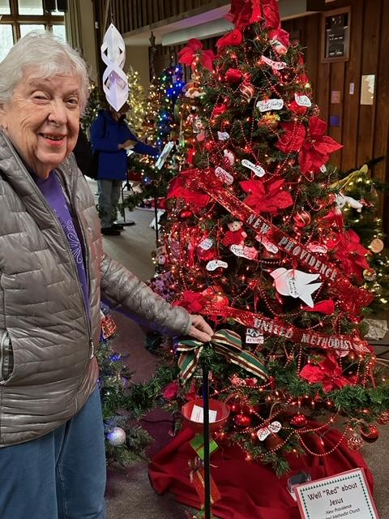
UMCOR
Our church received a heartfelt thank you letter from Umcor for our November donation to their Disaster Response and Recovery. Well done, NPUMC!!
Special Birthday Request
Marion Snyder, a long time congregant of New Providence United Methodist Church (NPUMC), will celebrate a very special birthday in January. She will experience her 102nd birthday on January 20. Blessings to her!!
As Outreach volunteer I would like to prepare a NPUMC birthday “gift” of many birthday cards for Marion similar to our endeavor for Leonard Blessing’s 103rd birthday. I collect all your cards in a box, wrap the box as a birthday gift and mail/bring it to her.
I would hope that you would prepare a card for her. You can utilize a birthday card, a “thinking of you” card or a note card to send Marion a personal message on her special day.
I will have numerous cards available at church on two consecutive Sundays, Jan. 7 and Jan. 14, so that those of us who are in the building on those Sundays can write cards during coffee hour.
If you will not be with us on those dates, you can still prepare a card for Marion. Please mail it or deliver it to the church by Jan. 15 so that your card can be included in her 102nd birthday “gift.”
I thank you in advance for enveloping Marion with your positive energy.

Lynn Franklin

LINC
Sally reached out to Abby asking if they were low on any of their donations. It appears they are in need of hygiene products.
Should you wish to donate, please leave your donations in a bag in front of the wire racks to the left as you enter the LINC room.
The Franco’s celebrate the holidays…
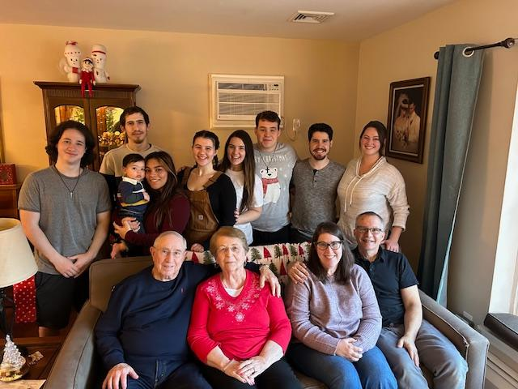

Having everyone home for Christmas was a joy this year…especially with the addition of Miles! He will turn 1 later in January….HAPPY BIRTHDAY, MILES!!
LEONARD
I had such a nice chat with Leonard yesterday! He was happy to hear from me and was his typical engaging self. I know he would enjoy hearing from you also…704-246-7766. Please know it’s best to let it ring for a good bit of time.

DECLUTTER & SAVE THE DATES

Sale days: Thursday, Friday, and Saturday, March 14, 15, and 16. Church member donations accepted mid-January, Community donations in February. We are receiving drop off requests already as people are doing New Year decluttering, downsizing, and reorganizing their “stuff”.

I have also had volunteer helper requests from outside of our congregation and encourage each of you to consider bringing a friend during our preparation for the sale. It helps us and spreads the word about the work of our United Women in Faith.

I will be updating you all regularly…..

Blessings and thank you for being disciples in the community of New Providence through your work,

Sally Hoffman
Donations: Household items, seasonal decorations, toys, games, records, small working electronics, tools, linens, small furniture, baskets, collectibles, puzzles, and if I forgot to list it, contact me. ❤

Wondering which of our elves was behind our Xmas mugs??
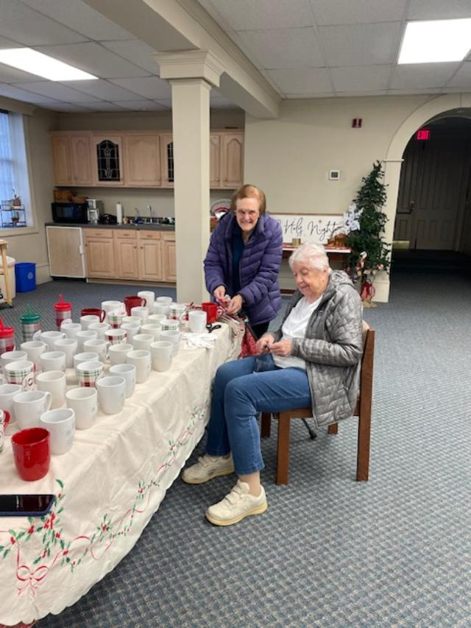
THANK YOU TO BOTH PAT AND CLAIRE!!
Stewards of the Earth Committee Newsletter Jan, 2024
Julie Lister

“All creation is the Lord’s, and we are responsible for the ways in which we use and abuse it. Water, air, soil, minerals, energy resources, plants, animal life, and space are to be valued and conserved because they are God’s creation and not solely because they are useful to human beings. God has granted us stewardship of creation. We should meet these stewardship duties through acts of loving care and respect."

From Social Principles: The Natural World in The Book of Discipline of The United Methodist Church. © 2016 by The United Methodist Publishing House. Used by permission.

In early October, 2023 the Earth Care Action Committee met to decide how to restructure the organization of the Serenity Garden and the Giving Garden as well as other Earth Care projects such as the recent plastic recycling project. These committees will now be subdivided into three sub-committees: the Serenity Garden, the Giving Garden and Conservation Action sub-committees. We believe that this work supports the mission of the Church to care for the Earth as described in the Book of Discipline. We urge you to take a closer look at the above mentioned article from the Book of Discipline which explains many topics of concern, from care for the Earth itself to Food Justice. We invite you to come and join any of these sub-committees and in the coming months we will keep you up to date through this newsletter with our activities.

Why Grow Native Plants? (a note from the Serenity Garden )

In a recent article in Gardener News from Hubert Ling of the Native Plant Society of New Jersey he writes that “of about 2,000 native NJ wildflowers, our Department of Environmental Protection lists 850 as species that are endangered or of concern.” This is a very worrying trend but there is much we can do to help. This coming Spring the Great Swamp Watershed association will again be having their very successful native plant sale. Also, the Serenity Garden committee will be dividing many of the native plants that have grown in abundance and offering them to our congregation. So please don’t miss out on these great opportunities to increase the numbers of native plants in your gardens or in your containers! Watch this space!

If you would like to volunteer please contact Linda in the Church office or call Julie Lister at 908-400-64

Our church staff sends a heartfelt “Thank You” for your generous staff appreciation gifts. Please know it was much appreciated by all!

January Dates

January 5th Beth Troutman’s birthday
January 14th Eat, Pray, Knit group resumes after service
January 21st Church Council 2024 Planning Meeting Luncheon
January 25th Bruce Kennedy’s birthday

We are presently in the planning stages of putting together a “craft event” for us to share fellowship and fun…..be on the lookout for an update on this soon!!

Our 2024 Coffee Hour and Alter Flowers signup are up and posted. Best to be proactive and get dates that work best for you.

Blessings,

Linda

