Welcome to the February newsletter of the NPUMC…
where indeed we have a busy month ahead of us! So let’s get started…
FEBRUARY 10th – LINC is hosting a fund raiser entitled Heat & Sweet Showdown which is their 1st annual chili and pie competition. The event runs from 3:30-8:30PM and will be held in Fellowship Hall.
If you are interested in attending this fun evening, please contact Claire Stang for your entrance ticket.
FEBRUARY 11th – Coffee Hour will once again get into the excitement of the SUPERBOWL!! Several congregants will provide their favorite soup which we round out with additional dishes to make for a hearty & fun lunch.
Please bring cans of food/hygiene products for LINC.
It’s a great way to “kick off” the Super Bowl!! Go Taylor!! ;-))
BAGS NEEDED
The church is looking for plastic/cloth shopping bags for our book mission and for LINC. This is an ongoing need as we use them to deliver both our books and food through the LINC mission. Please drop them off at our church office between 10:00-2:00pm or bring to church on Sunday. Thank you!
A delivery of 30 bags of books was made today to our counterpart Barbara in Newark. She sent a lovely note back to us…”Thank you so much… your love and dedication to this project is so inspiring for all of us and it so gives hope and inspiration for all of tomorrow’s promise!!!!❤
We are building bridges that will last in perpetuity”

CSA PASTA DINNER
The CSA of New Providence is once again hosting their pasta dinner in conjunction with the town’s Lions Club.
SUNDAY MARCH 3RD
3:00-7:00PM
DECORSO COMMUNITY CENTER
15 E. FOURTH STREET
NEW PROVIDENCE
TICKETS ARE $15.00 A PERSON WITH UNDER 5YRS BEING FREE
BASKET RAFFLE AND 50/50
PURCHASE TICKETS AT THE DOOR OR WITH THE QR CODE ON THEIR WEBSITE
SNOW DATE March 10th
THRIFT SALE PREPERATION HAS BEGUN
We started our sorting process today. You would be amazed at the number of donations we have already received! It’s become obvious that we have made an impression on the surrounding communities based on past thrift sales and how we have handled them. People are excited to “unload” their treasures and they look forward to our sale days to get a “deal”…it’s a win/win!
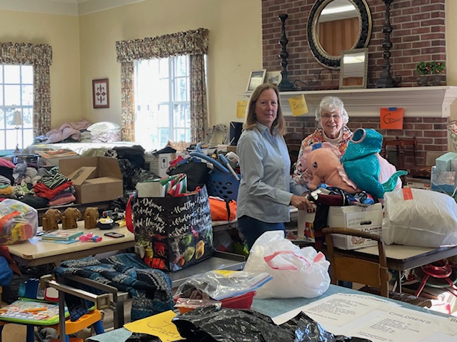
Sorting is happening Monday thru Friday starting around 10:00am. Any time you can give to help with this process is greatly appreciated!
Day one we had Sally, Mary and the Gossett’s sorting through the donations. Today we have Gail, Kecia and Sally sorting and organizing our donations!

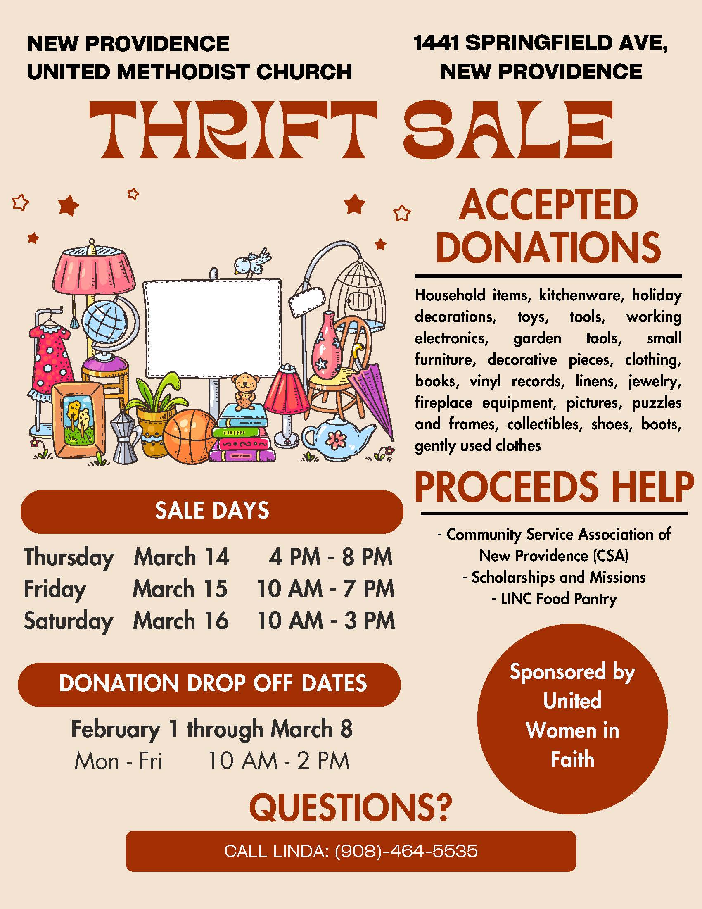

STEWARDS OF THE EARTH COMMITTEE
“All creation is the Lord’s, and we are responsible for the ways in which we use and abuse it. Water, air, soil, minerals, energy resources, plants, animal life, and space are to be valued and conserved because they are God’s creation and not solely because they are useful to human beings. God has granted us stewardship of creation. We should meet these stewardship duties through acts of loving care and respect."
From Social Principles: The Natural World in The Book of Discipline of The United Methodist Church. © 2016 by The United Methodist Publishing House. Used by permission.
According to Punxsutawney Phil we are going to have an early spring. If you are like me for the past couple of weeks you have been inspecting the trees and the plants around you for signs of new growth. Today, February 5, our Stewards of the Earth Committee met to plan for the coming season. The Serenity Garden is still sleeping, but if you are interested in learning more about native gardens and protecting pollinators there are many resources. On Thurs. Feb 29th, Summit Free Public library will be presenting a talk online, “Planting a Native Garden.” Also, the Great Swamp Watershed Association’s excellent webinar series ‘GSWA Plants for Pollinators” is in progress but you can still sign up at www.greatswamp.org. Their native plant sale returns again this year for April 1st through April 19th. One advantage of buying native plants here is because they are free of harmful pesticides, such as neonicotinoids that are harmful to our pollinators.
Our newly formed Conservation Action sub-committee is looking at ways that we, the friends and members of NPUMC, can act to care for and protect our planet. Top of the agenda is planning for Earth Day on April 22. The global theme this year is Planet vs. Plastics. Plastics have made our lives easier in many ways but their impact on our environment is alarming. As Kathleen Rogers, President of EARTHDAY.ORG points out: “Now plastics do more than surround us; we have become the product itself - it flows through our bloodstreams adheres to our internal organs, and carries with it heavy metals known to cause cancer and disease.” The Conservation Action wing of our Stewards of the Earth Committee will be exploring ways in which we the members and friends of NPUMC can help build a plastics free future for generations to come.
If you have any questions or need more information about the Serenity Garden, Conservation Action or the Giving Garden contact Linda at 908-464-5535. Linda will direct your question to the appropriate person.
BLACK HISTORY MONTH RESOURCES…BY SALLY HOFFMAN

The observance of Black History Month in the life of the Church can take on many forms. Yet any celebration without gratitude and appreciation of the contributions from the Africana traditions to the music life of the whole church would be incomplete. To give a taste of the scope and variety of musical styles and genres, Discipleship Ministries presents a four-part video series, “Lift Every Voice: A Celebration of Song from the Black Church Experience” with Bishop Ernest Lyght and the Rev. Dr. Cynthia Wilson, Executive Director of Worship Resources.
This resource may be found on You Tube by clicking on the above Link.

Or you can choose from among the following video listing:
- Black History NOW
- Black History Month Around The World
- Black History Month Around The World: How Much Do YOU Know?
AND be on the alert for a change in the bulletin board in the hallway leading up to the sanctuary.

METHODISM COMES TO AMERICA: THE BRISTOL CONNECTION

We would like to draw your attention to an event hosted at Drew's Craig Chapel that might be of interest to local UM congregations.

On Thurs Feb 29, at 6pm, David Worthington, the Global Ambassador for John Wesley's New Room, will be giving a lecture on the connection between England and US Methodism. David is a phenomenal speaker and I think this lecture would be a great event for UM members who are interested in learning about our British roots. Please help GCAH spread the word about this event! It will be a great learning opportunity for all. Hope to see you there!

Shalom,
Ashley Boggan D., Ph.D.
General Secretary..36 Madison Avenue, Madison, NJ 973-408-3191

TO ALL OUR GREEN EARTH PEOPLE…COURTESY OF LYNN FRANKLIN
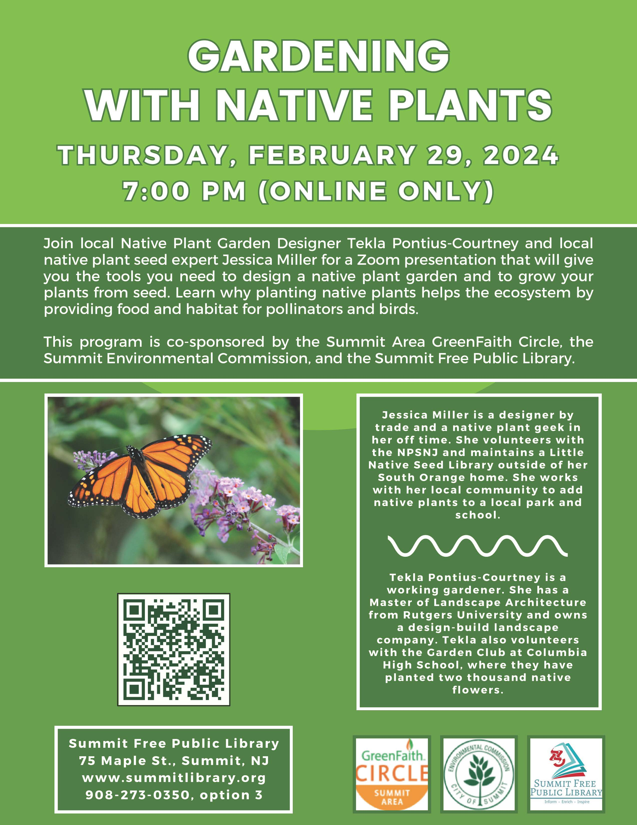
Don't miss out on this fantastic Garden Talk with a Native Plant Garden Designer and a Native Plant Seed expert. Register below or see attached flyer

https://summitlibrary.libcal.com/event/11576611

FEBRUARY HAPPENINGS
2/10 LINC FUND RAISER
2/11 “SOUPER BOWL COFFEE HOUR”
2/14 10-12 ASH WEDNESDAY DISTRIBUTION
2/15 11:00 EARTH DAY MEETING
2/19 PRESIDENT’S DAY OFFICE CLOSED
2/26 7:00PM CHURCH COUNCIL MEETING
BIRTHDAYS
2/02 MIM WIELAND…. HOPE IT WAS FILLED WITH LOVE & FAMILY
2/04 ALLIE DAVIS HAPPY 95TH YOUNG LADY!
2/12 ELIZABETH HOFFMAN TURNS 14
2/28 PAT KENNEDY…. YET ANOTHER YOUNG LADY CELEBRATION

Blessings,
Linda

