SWIM AND SPORT CLUB
April 2024 MEMBER NEWSLETTER

UPCOMING EVENTS – MARK THOSE CALENDARS!
Sunday, Aprill 7th – Spring Workday
Saturday, April 13, 2024 - 1pm - 5pm Paint and Sip in the Clubhouse
Sunday, April 14, 2024 - Spring Workday
Sunday, April 21, 2024 - Spring Workday
Sunday, April 28th – Spring Workday Rain date
Saturday, May 4th – Morris County Rugby Tournament 10 AM
Sunday, May 5th – Member Meeting 3PM followed by Cinco De Mayo Celebration
Sunday, May 11th – Mother’s Day Bruch 11AM
Saturday, May 18, 2024 – Music on the Lawn 11AM

President – Alison Manchester

I would like to thank all the members that have volunteered their time so far this year. The Club runs on its volunteers, and we appreciate each and every one of you!

I'm going to pull together a pool committee to help run the pool - gate duty, keeping the play area clean, weeding, skimming the pool during the season etc., if you would like to volunteer in any way please either let me know if you see me at the club or shoot me an email at acmanchester23@hotmail.com

Vice President Entertainment – Wendy Stanton

Sat April 13th - Paint and Sip – We will begin painting at 1:00, so come early to get settled and grab your drinks! Join your SSC friends for a fun adventure in painting. Pinot's Palette will be coming to the clubhouse to bring out your artistic flair, but mostly just to have some fun! We'll be painting 'Lilacs in a Glass' which should be lovely. Members and their guests are welcome to join the fun. A $5 guest fee will be collected the day of the event for any guests in attendance. We’ve done this a few times in the past and it’s lots of fun so come on down and enjoy the day! If you would like to bring a snack to share with everyone that would be lovely.
The link to register is https://www.pinotspalette.com/hackettstown/event/761845 and payment is made directly to Pinots Palette.

If for some reason registration cannot be done through the site, just let me know at SSC1928Entertainment@gmail.com

Let the Season begin!! Coming soon info on a very busy couple of weeks in May!

May 5th - Cinco de Mayo Celebration May 5th following the member meeting - fully catered Mexican Fiesta Fun! $17 per person - RSVP by May 1st to SSC1928Entertainment@gmail.com

May 12th - Mother's Day Luncheon Fully catered, menu TBD with more info coming soon! $40 per person - RSVP by May 8th to SSC1928Entertainment@gmail.com

May 18th - Music On the Lawn – OPEN TO THE PUBLIC!! Non-members must purchase tickets and parking passes. CLICK here to send the link to your friends, the more the merrier!

All are invited to attend the SSC for this NEW music event to kick off our 2024 season! Bring a chair, blanket or whatever you’d like to get comfortable for an afternoon of Blues and good ole Rock & Roll! IMPORTANT NOTE - This event will be held rain or shine.
The day will feature the following performers: The Trevor Power Band, Tequila Junction and Dean Shot.
Tickets:
Adult Advance Single $25
Adult at the Door $30
Youth (3-14) $7
Youth under 3 Free

SSC Club members can attend for FREE!
The link to buy tickets is here: https://www.eventbrite.com/e/music-on-the-lawn-2024-tickets-805862164427?utm-campaign=social&utm-content=attendeeshare&utm-medium=discovery&utm-term=listing&utm-source=cp&aff=ebdsshcopyurl
The link to the FB Event is here: https://www.facebook.com/events/726523656076558
Please spread the word and help make this event a huge success!

Vice President Clubhouse Manager – Ryan Baumbusch

There are already lots of private events on the schedule throughout the year and we are anticipating more. Please be sure to check the top of the newsletter as well look at the SSC Events Calendar to see what’s going on and what areas of the club may be closed to members due to these events. We will make sure that there is always at least one area open for club members to use.

To access the SSC Events Calendar please click on the link below:

https://calendar.google.com/calendar/u/0?cid=c3NjMTkyOGVudGVydGFpbm1lbnRAZ21haWwuY29t
The bar captains are always there on their assigned weekends to open and close, but we need more people to get involved.
Beginning Memorial Day weekend and ending Labor Day weekend the bar will be open on Saturdays and Sundays. We are going to use a 2-step process on staffing the bar this year. We will start out with sign-up genius and if we don’t get the volunteers then bar duty will be assigned to permanent members. If you are assigned a shift and can’t make it, it will be your responsibility to get someone to cover. This isn’t a difficult job and it’s a great way to meet new members!
Anyone tending the bar should be asking for a membership card or guest pass to ensure that we are only serving those that are allowed per our liquor license. If a member shows a guest pass, please be sure they sign the guest book prior to serving them.
Fun Fact - While the current calendar (Gregorian calendar) has April as the fourth month of the year, that wasn't always the case. In the Roman calendar (Julian calendar), April was the second month of the year. January and February didn't exist.
Permanent & Annual Dues – Colette Baumbusch & Jason Singh
Permanent member dues are now late. Please be sure to add the $25 late fee to your dues when submitting them.
Social Memberships – if they haven’t been paid, please submit your payment or bring a check with you prior to coming up for events or to drink at the bar.
If you are reading this and haven’t received an invoice OR you’ve paid your dues and haven’t received your membership card, please reach out to Colette or Jason ASAP.
Do you love being a member of the SSC? Our best resource for new members is our existing members. If you know of people looking for new things to do, new friends to make, and new memories to be made, bring them by for an event or just to hang out and share a laugh.
If anyone would like more information on membership or you have any questions (like how you become a permanent member), please contact Colette for Permanent Membership or Jason for Annual Membership at ssc1928membership@gmail.com
The SSC would like to formally welcome new members Bart & Barbara Martinez to the Club! We’re so excited you’re joining us and are looking forward to meeting you!
***ALL members and their guests MUST show their membership card or guest pass if it is requested at any time***
April is World Autism Month, in which we celebrate autistic individuals and their unique contributions. Let's recommit to building a more kind, fair, and inclusive world for every American with Autism Spectrum Disorder.
Sports Director - Steve Varrone
The Morris County Rugby Club is scheduled to hold a tournament at the SSC on Saturday, May 4th. There will be 6 teams comprised of 2 Men’s teams, 2 Women’s teams and 2 Master’s Teams. The tournament starts at 10 AM should you want to grab a chair and watch. We will be opening the bar at about noon for those members that want to come down and if you would like to help behind the bar, I’m sure that will be welcomed.
Fistball practice is going to start on April 21st – if you’re interested in finding out more about the game, or would like to attend practice and give it a try, please contact Steve at svarrone11@gmail.com and he will put you in touch with the correct people.
What IS Fistball you ask?
Fistball is a return game in which two teams face each other on two half-fields, similar to Volleyball. They are separated by a center line and a net-like ribbon that is stretched between two posts. The net height differs between categories, for women a net height of 1.90m applies. Tape and post are not allowed to be touched by a player or the ball.
Each team consists of five players. The goal is to fend off the attacks of the opponent and to play the ball back into the other half field, inaccessible to the opponent. In contrast to Volleyball, in Fistball the ball can only be played with one arm, also in the defense. In addition, the ball may bounce once on the ground per player, as in tennis. Each team is allowed to touch the ball 3 times, whereby no player is allowed to touch the ball twice.
It is not known exactly when the Fistball game was invented. What we know is that the roots of the game will be in the southern part of Europe, possibly in Italy. Already three centuries BC a game is transmitted to have originated there in which a ball made of leather had to be hit with arms and fists. The Fistball game was first recorded in writing in 240 AD. In 1555 Antonio Scaino wrote the first rules for an Italian national sport, the Gioco del Pallone, in English balloon game.
It was not until 1870 that Georg Weber introduced the sport of Fistball in Germany. Mainly practiced by gymnasts as a ball sport to relax from the daily routine. Fistball was soon considered as a gymnastics sport. It was at this time where Fistball spread to the surrounding, mainly German-speaking, countries. And German emigrants carried the sport to all continents, especially to South America and South West Africa.
Fistball today
The modern Fistball is mainly played in Europe and South America, occasionally also in North America, Africa and Asia. It is most widespread in countries with a high ratio of German-speaking emigrants. Thanks to the efforts of the International Fistball Association (IFA), more nations have been getting involved and playing Fistball.
Fistball is not an Olympic sport, but it has been represented at the World Games for years. The SSC has proudly been represented in the World Games by both players and coaches. Our members have represented the United States on the IFA on their board and are working hard to make Fistball more well known.

Alternative Sports Director – Scott Ireland
On the heels of last year’s stunningly successful inaugural tourney, The SSC Alternative Sports Network, in partnership with the NJ Chapter of the World Foosball Association, announces that signups for the 2nd Annual SSC Foosball Tourney will be accepted starting on May 15th.

1st round matches are set to start on Sunday June 9th as the opening date for the Swim & Sport Club 2024 Foosball Tournament!

The tournament is open to both men & women. Teams will be mixed couples and all SSC members are invited to join in the fun and play!
(And don't fret too much on the dates ...the tourney will last a few weekends...we'll get your match(es) in !!)

Details on team selections to follow!

Contact ASN Exec. Dir. Scott Ireland with any questions.
rvrpilot@gmail.com
Fun Fact - On April 6, 1896, the first modern Olympic Games were held in Athens, Greece, after a 1,500-year hiatus. The event marked the revival of the ancient games and was organized by the international Olympic Committee founded by Pierre de Coubertin in 1894.
.

Jugend – Lindsey Underwood
Thank you to all who came out and made the SSC Egg Hunt a success. Our Jugend enjoyed a few games on the field before they set off to hop around the Biergarten to search for their eggs. All the children had a wonderful time and are excited for summer at the SSC. Thank you to Alison for all her help making the day great!
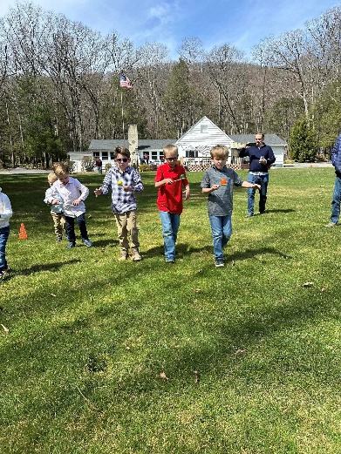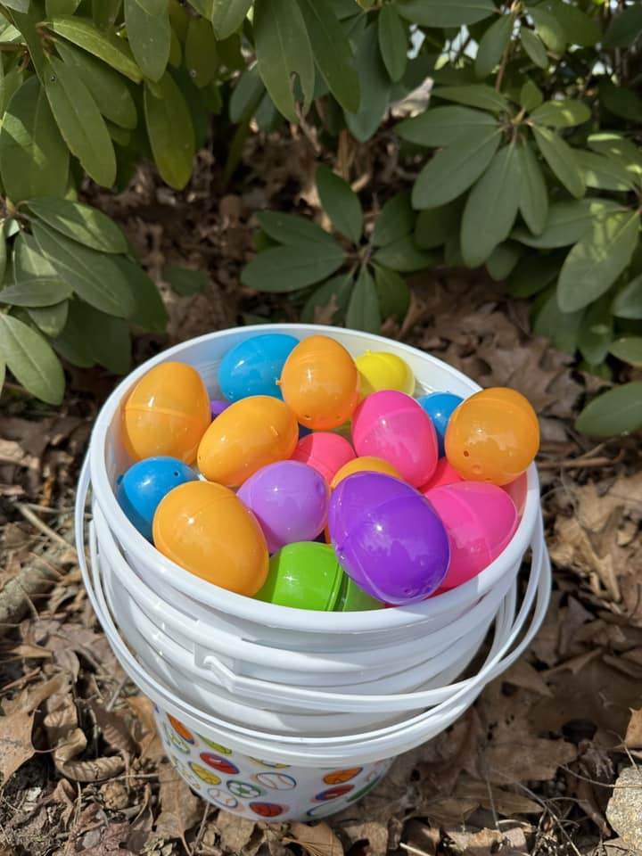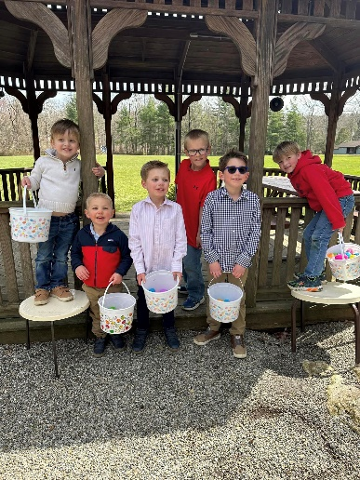
Holding Company – Gretchen Braunschweiger
WORK DAYS: Our second official Work Day at the Swim and Sport Club before we open for the season is scheduled for this Sunday, April 7. We expect a lot of log splitting, some more leaf cleanup and the pool should be drained to assess what is needed for the upcoming Summer season. For those who do not like working outside, I am sure the Clubhouse Manager would also appreciate help giving the bar and clubhouse a deep cleaning, wood polishing, etc. as well as Biergarten cleaning when it gets warmer.

We hope to start work at 9 AM, with breaks in between for a late breakfast & lunch provided by the Holding Co. and finish up around 4 PM. The SSC Work Days date back to the creation of our beautiful Sportpark by member volunteers in the 1930s, and provide a unique experience to help make the SSC beautiful while getting to know your fellow members better. We look forward to seeing everyone up there!

Additional Work Days scheduled are:
Sundays, April 14 and 21*
*Some Work Days may be moved to Saturday to avoid needing the extra Rain Date.
Rain Date: April 28

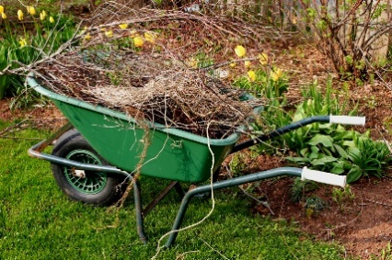

BUNGALOW FOR SALE:
Bungalow #8 is for sale. If you are interested, please contact Laurie Banta at laurie.banta1126@gmail.com
Bungalow ownership is for SSC Permanent Members only. If you would like to find out what is necessary to become a Permanent Member, please contact SSC1928membership@gmail.com for more information.

Things & Stuff – Alicia Varrone
The flowers are coming up, the trees are starting to get buds and leaves and the bright yellow forsythia is showing its splendor. Spring is officially here!!! I’ve had the opportunity to walk around the grounds recently with my trusty side kick Bogey and we’ve enjoyed watching it coming back to life. The brook is babbling away thanks to all the rain that we’ve had, the grass is starting to get green and lush and bungalow owners are starting to appear while they are working on projects to get the bungalows ready for opening. Believe it or not, this is one of my favorite times of the year at the Club. It’s peaceful and quiet (until those leaf blowers start up – you know who you are LOL) and you get a feeling of serenity that you don’t get in the middle of summer.
When you see the friends you haven’t seen since fall last year, you get the BEST hugs and it’s wonderful to sit and catch up and just “be”. I have been a member of the SSC for 38ish years and have made some wonderful friends and made some great memories with them. Some of my favorite times are those first hugs of the season, seeing what’s new and enjoying those friends who are more like family. I feel very blessed to call my very first friend at the SSC one of my closest friends today. I have made new friends in the last couple years that I can’t imagine haven’t always been in my life. That’s the nice thing about the Club – it connects you with people you might never have met in a way that turns them into family.
As the weather starts to warm up and God willing the rains slow down, I look forward to watching the bungalows come alive, the snowbirds start to arrive, the pool open up for its last season, attend the wonderful events we have planned and to enjoy another summer at the SSC. Some of us have to find our new normal and learn to live the SSC life in a different way, but with so many wonderful friends there to help, hopefully we can support each other like family is supposed to and make that transition as easy a one as possible.
Happy April birthday wishes go out to:

Scott Ireland
Marty Grossmueller
Laurie Heuple
Carl Braunschweiger
Jamie Gilbert
Michael Heuple
Jen Hunt
Steve Grossmann

Happy Birthday to all those that I may have missed. If you would like to send out birthday or anniversary wishes, please drop me a line at swimandsportclub@gmail.com
Fun Fact - People who are born in the month of April have the birthstone of Diamond. The month’s birth flower is the Daisy or the Sweat Pea. When it comes to zodiac signs, March 21 up to April 19 falls under Aries, while April 20 up to May 20 falls under Taurus.

Happy Retirement!! Our caretaker of many years, Tom Cramer, was originally set to retire at the end of October but the call of retirement beckoned him early and he officially retired at the end of March. We thank him for his many years of service & hard work around the SSC and wish him the best.
It’s a time-honored tradition to represent the SSC at the Annual Steuben Day Parade in NYC! Come walk with us on Saturday, September 21, 2024! Shuttle bus pickup at 8:30am @ the SSC and return at about 6pm. All members & guests are welcome. Attire: white shirt & black pants. There will be a cost for the shuttle bus but we won’t know how much until the responses are in. Please RSVP to Stephanie Singh (stephanieasingh@yahoo.com) if you would be interested in marching. I personally did it for the first time maybe 4 or 5 years ago and it was a fun experience!
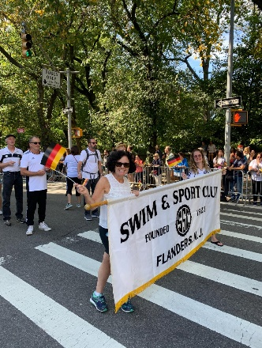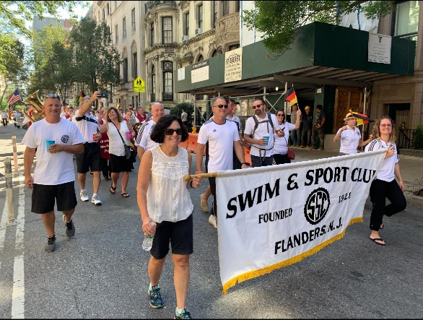
The SSC has lost 2 of its 4-legged members and they will both be greatly missed. Holly didn’t make it down to the grounds from the bungalow often, but she was happy to welcome all visitors who stopped by her bungalow for a visit – such a sweet girl! Much more well known was Oakley – he was one of the club’s pup ambassadors who was happy to welcome all to the Biergarten or out in the fields. He was large and in charge but super sweet and was happy to get some scratches and treats and more than happy to help you finish your meal if you were full. Rest easy sweet pups – you will both be greatly missed.
Reminder - Corks & aluminum can tabs (i.e. soda and beer can tab openers) - My husband and I are collecting both so please put them aside for us and bring them up whenever you come up. The corks need to be real cork – not rubber - and we just need the tab not the can. If one of us isn’t there, please just ask the bartender on duty to put them aside for us. There is also a cork holder behind the bar on the shelf so you can put them in there and we will collect them. We appreciate your help!
The bears are awake, and babies have been born so please be sure to empty & secure garbage cans, keep the lids down on the dumpsters and as a reminder, bird feeders, while lovely, attract the bears so please don’t hang them at your bungalows.
Finally…as many of you know, when we sold the property from Emmans Rd to our fence line along with the new field (behind the side and swings), it was sold to the Township of Roxbury. Their plan was to install hiking trails through that property and up the mountain, so it connected the Emmans Rd Greenway to Veterans Memorial Park. It would seem that plan has stalled and has hit a dead end. This article explains what happened:
Roxbury, NJ Top Stories | TAPinto
That’s it for this month. If there’s anything you’d like to see in a future issue, or you have any news you’d like to share, please let me know.
Hope to see you all soon up at the Club!
Alicia Varrone
Publicity

